

**Food Recovery Network**

**PROJECT REPORT**

***Submitted By***

JEEVANA TUNUGUNTLA, GOUTHAM MARIKANTI, RAKESH VISTARAKULA, SAITEJASREE RAMALA

FOR THE PARTIAL FULFILMENT OF THE COURSE

CS551-ADVANCE SOFTWARE ENGINEERING

FALL - 2014

[Type the document subtitle]

**Project Deployment:**

GitHub URL:

**Project Video:**

YouTube URL: <https://www.youtube.com/watch?v=g8eQChWJJD0>

**User Manuel:**

**Problem Situation:**

In the food supply chain, food is supplied and consumed in many ways - hotels, restaurants, canteens, house hold etc. To satisfy the hunger of people, millions of tons of food products are supplied and consumed, but at the same time vast portion of the food is getting wasted in the form of leftover food in the above mentioned supply chain. With huge quantity of food is getting wasted, there are so many people who finds it difficult to have at least one meal a day. Our project goal is to provide a platform, using which unutilized food will be distributed to the needy.

**Solution:**

We are designing a mobile application to show how much food is utilized and how much food is wasted in hotels, this data we are diverting to NGOs so that we can effectively use the unutilized food. We are going to show statistics for quantity of food conserved using our application. We are also categorizing food based on type, expiration date and provide the location. So that we are making sure that whatever we are supplying will not harm needy people and also to make it easy for the distributors to carry the food.

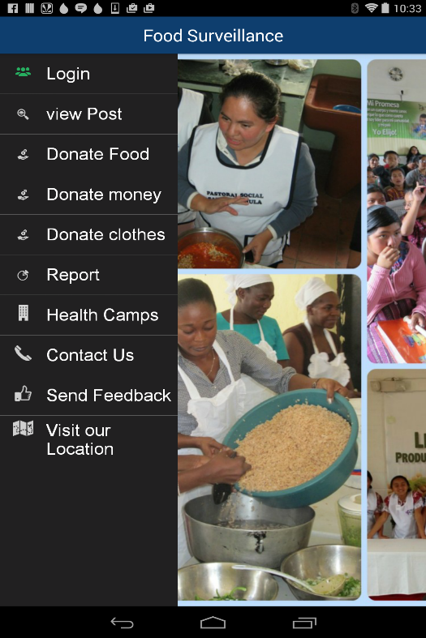 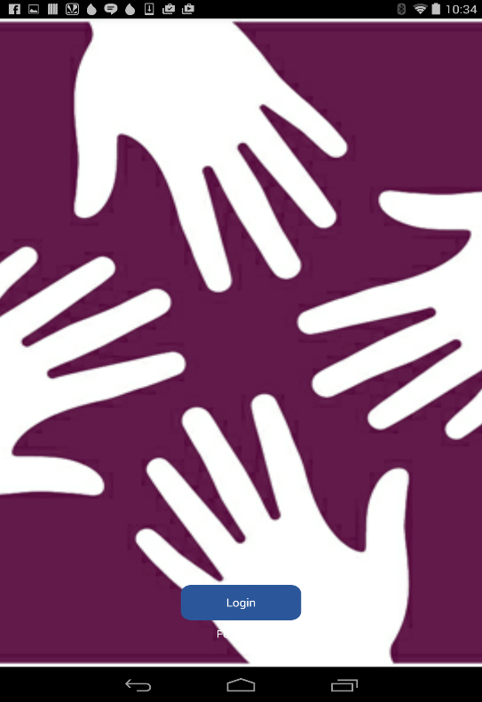

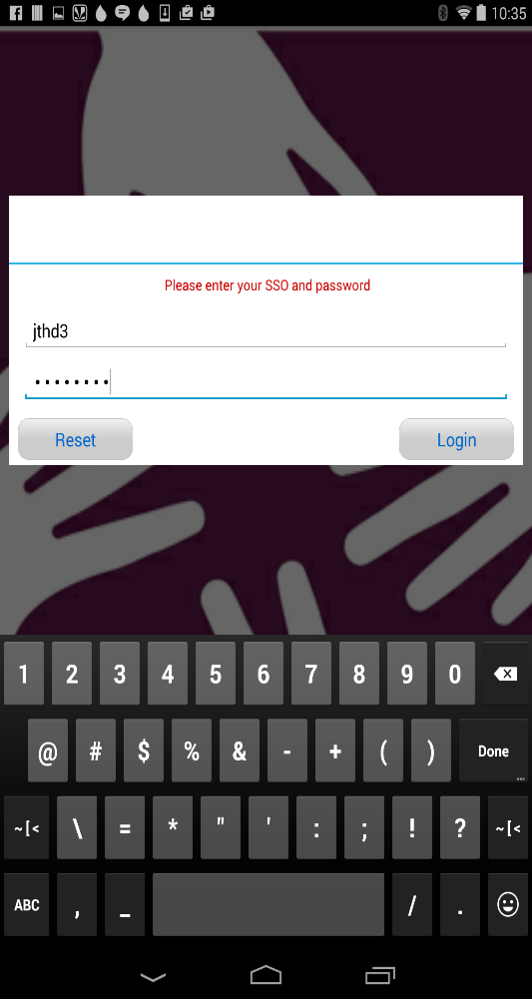

From the home page, once the user clicks Login, he is redirected to a new page where he can enter his credentials and log in or can continue as a guest.

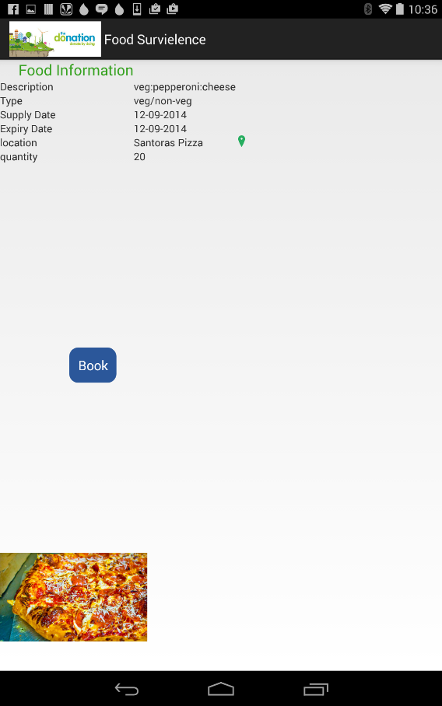

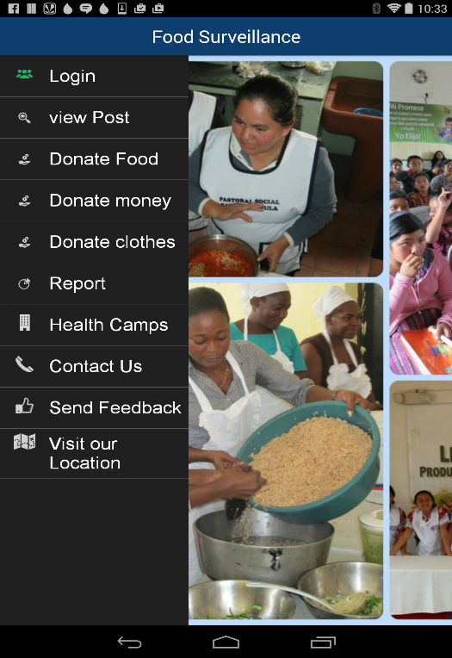 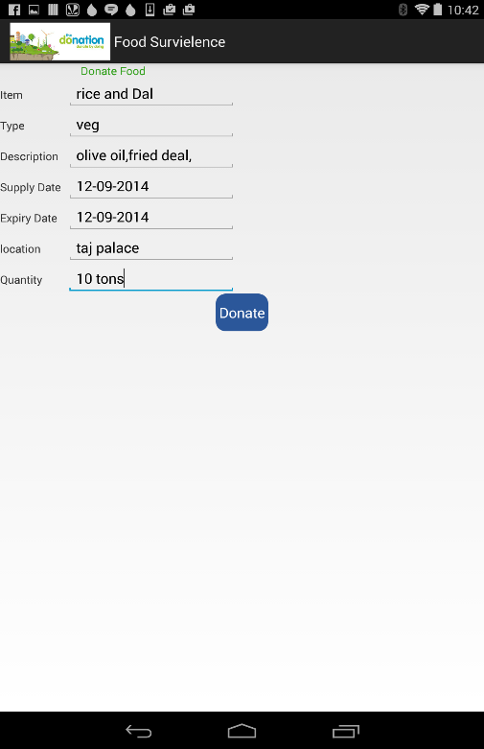

From the home page, once the user clicks Donate Food, he is redirected to a new page where he can enter all the details and click on Donate to donate food and this will now be populated in ViewPost page.

 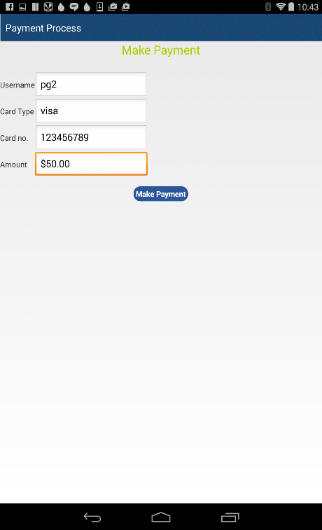

From the home page, once the user clicks on donate money, he is redirected to a new page where he will be asked to enter the details about how much amount he is going to donate and then the details will be submitted.

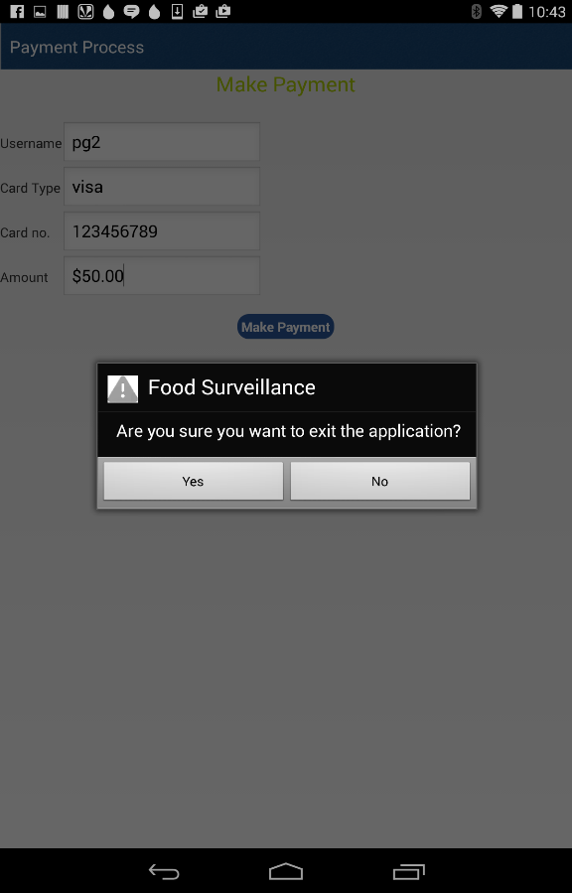

 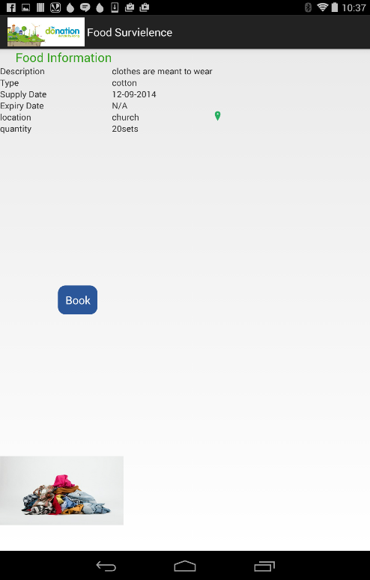

From the home page, once the user clicks on donate clothes, he is redirected to a new page where he will be asked to enter the details about the number of clothes and the details of the clothes and once he is done with all this he will submit the details entered and this is now populated in ViewPost page.

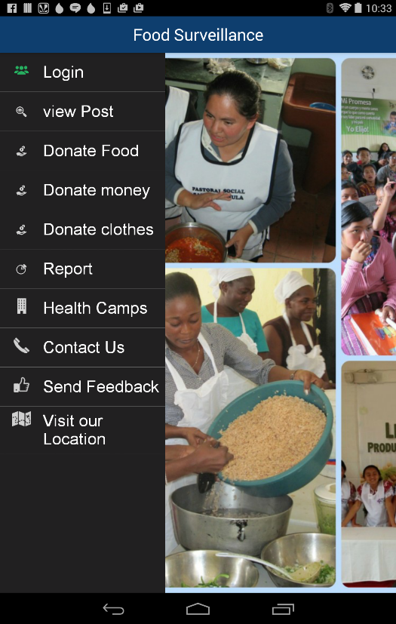 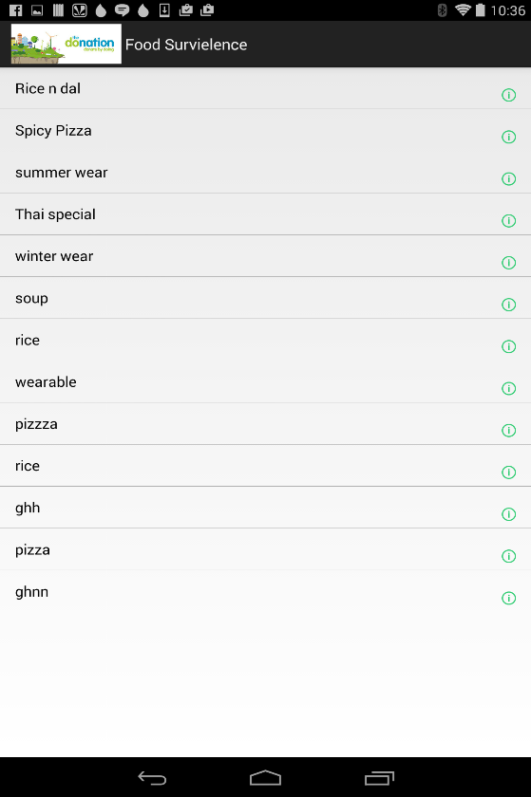

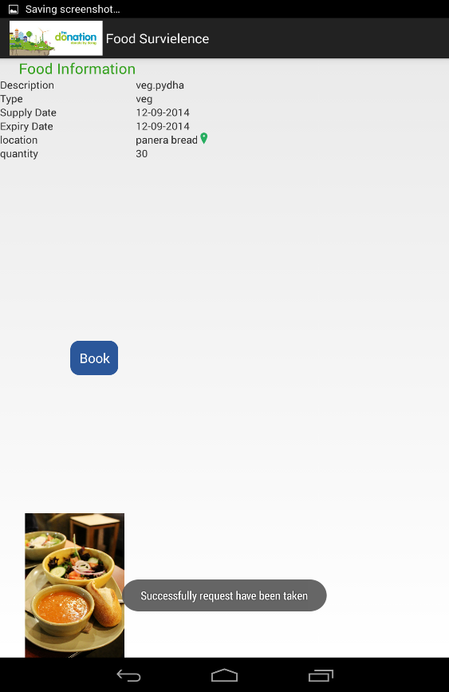 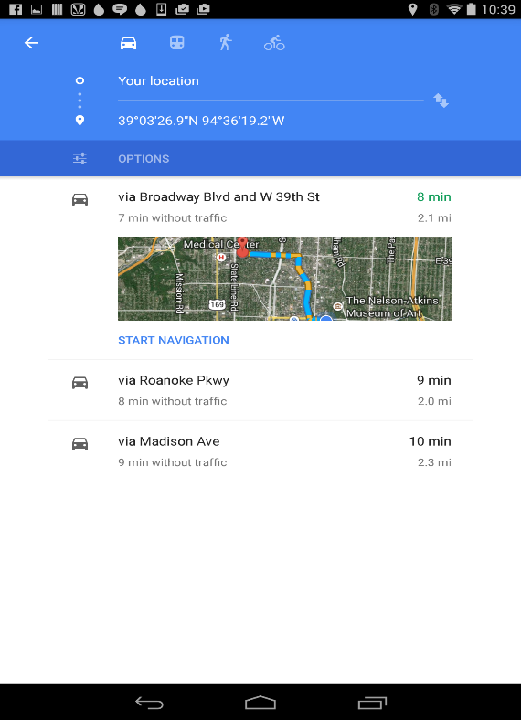

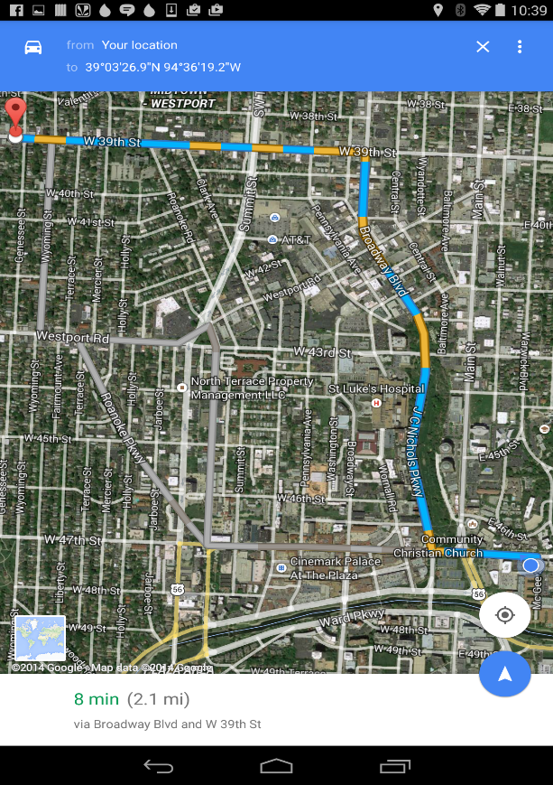

From the home page, once the user clicks on view post, he is redirected to a new page where he is shown all the data related to donate money, donate food and donate clothes like shown. When the user clicks on any particular post all the details about that post will be displayed along with a location symbol. If the user clicks on the location icon then he will be redirected to the google maps where he will be shown the current and the destination locations and the amount of time it takes to travel and also the shortest distance to the destination.

 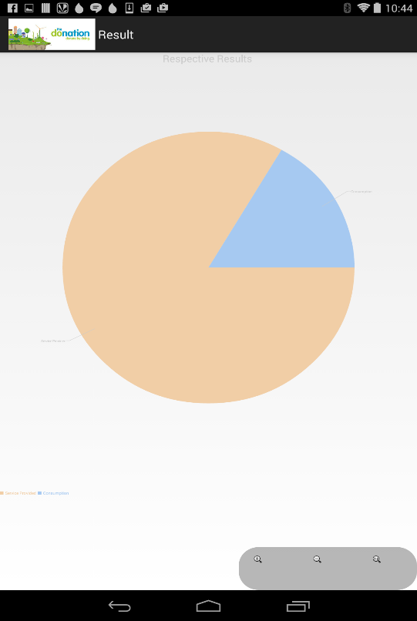

From the home page, once the user clicks on Report, he will be shown a pie chart which describes the number of services provided and the number of services used from them. This gives the idea of how many more services are available.

 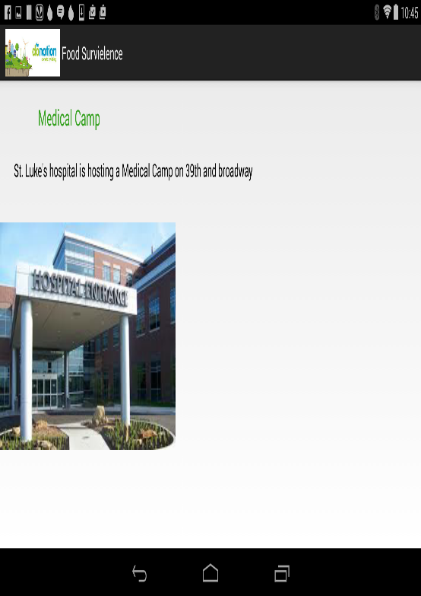

From the home page, once the user clicks on health camps he will then be redirected to a page where the user will be given all the details related to any of the available health camps like the date of the health camp, its location and the time.

 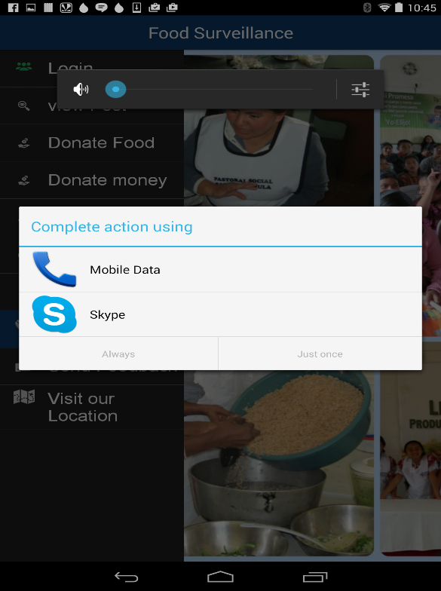

From the home page, once the user clicks on contact us he will then be redirected to a page where the user can contact like share opinions and also report problems about the site either by skype or by mobile data call.

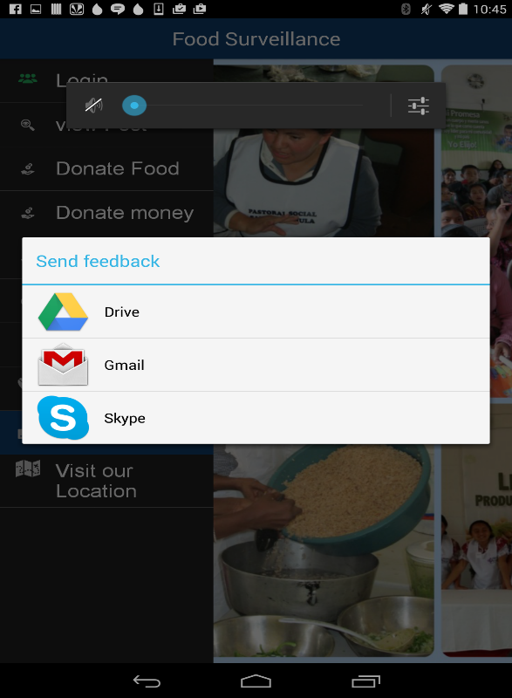

From the home page, once the user clicks on send feedback the user will then be redirected to a page where he can send feedback by Google drive, Gmail or also by skype.

 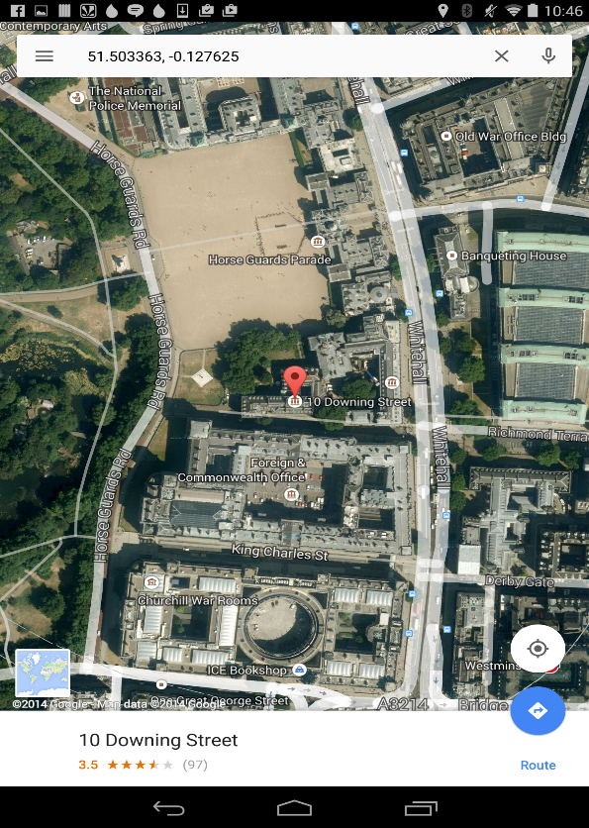

INCREMENT-1

PROJECT PLAN

In the food supply chain, food is supplied and consumed in many ways - hotels, restaurants, canteens, house hold etc. To satisfy the hunger of people, millions of tons of food products are supplied and consumed, but at the same time vast portion of the food is getting wasted in the form of leftover food in the above mentioned supply chain. With huge quantity of food is getting wasted, there are so many people who finds it difficult to have at least one meal a day. Our project goal is to provide a platform, using which unutilized food will be distributed to the needy.

***Project Goal and Objectives***

* **Overall goal**

Our main goal is to use the leftover food of restaurant/hotel chains and use to satisfy the hunger of the homeless and poor people.

* **Specific objectives**

We are designing a web application/mobile application to show how much food is utilized and how much food is wasted in hotels, this data we are diverting to NGOs so that we can effectively use the unutilized food. We are going to show statistics for quantity of food conserved using our application. We are also categorizing food based on type (i.e veg/non-veg), expiration date, frozen or normal, liquid or solid etc. So that we are making sure that whatever we are supplying will not harm needy people and also to make it easy for the distributors to carry the food.

* **Significance**

We will work towards diverting this excess food to the hunger struck areas and use it in an eventful and kind gesture towards humanity. Based on the type of NGO involved, food can be distributed to the different categories of the society.

**III. Project Background and Related Work**

**Existing work**

<http://www.statisticbrain.com/world-hunger-statistics/>

<http://www.fao.org/save-food/key-findings/en/>

<http://developer.android.com/training/index.html>

**Comparison**

We are filtering the gathered food based on type, expiration date and time. We are also getting approval from food department before sending our food to NGO’s. We are also providing routing services to NGO’s, thereby facilitating them to receive food by shortest way.

**IV. Proposed System**

1. **Requirement Specification**

* **Functional :** Our application will keep track of all the suppliers of hotel chains / food serving departments and the gathered data is filtered based on categories of types of food , food expiration get it approval from food health department and redirect this data to nearby NGO’s , our application also provides delivery details and routing information through google maps web service.
* **Non-functional:**

**System:**

Operating System: windows/linux

Ram: 2GB

Firewall: required

**Mobile**:

OS: Android, IOS

Ram: 4 GB internal storage

Android version: 4.0.3

* **Business Process/Workflow analysis**
* **Technical/business Requirements**

Front end: Java, C#, HTML5, CSS3, JavaScript, jQuery, Android framework

Back end: sql server

1. **Framework Specification:**

* **Assumptions and Principles**

We are assuming that hotel chains / restaurants will keep track of records i.e how much food is wasted in a day. Our system will retrieve those data and redirect those information to NGO’s.

* **System Architecture Diagram**

**Food Details in website/App**

**Food Provider**

**Food Distributor**

**Food required areas**

**Deliver the food**

1. **System Specification**

**i) Existing Services:**

Google map service

[https://maps.google.com/?q=Pizza&center=37.759748,-122.427135](https://maps.google.com/?q=Pizza&center=37.759748,-122.427135%20)

**ii) New Services to be built**

* **Class diagram**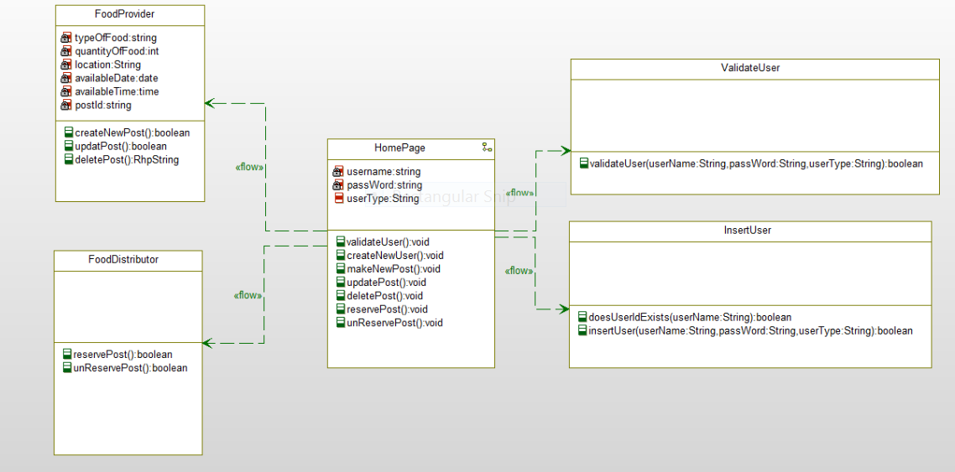
* **Sequence diagram**

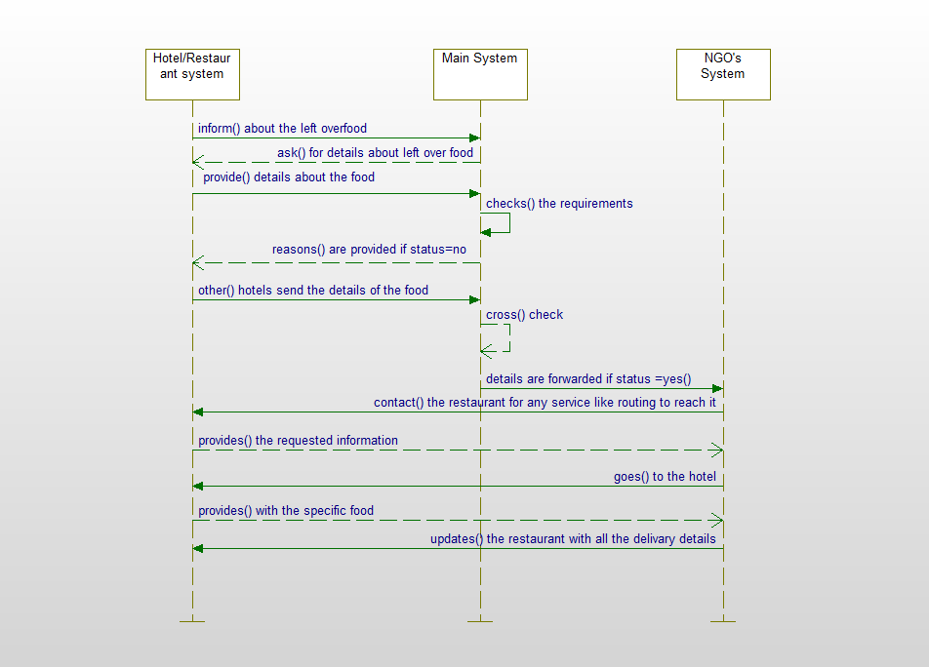

* **Service Specification** 
  + The system is informed about the left-over food by hotels/restaurants.
  + The system checks if the food meets all the requirements.
  + If the food doesn’t meet the requirements then the reasons are provides and if not, the details of the hotel/restaurant is sent to NGO’s
  + The NGO’s contact the hotel for any of the necessary services and then collects food.
  + Provide the delivery details of the food to the needy people.
* **Operational description:**
  + Firstly, the hotels/restaurants informs the system about the left-over food.
  + The system then checks if the food meets all the requirements before forwarding the details of the hotel to the NGOs system.
  + If the food doesn’t meet the requirements then the reasons are provides and if it does then the details of the hotel/restaurant is sent to NGO’s System.
  + The NGO’s System then contact the hotel for any of the necessary services like how to reach the hotel/restaurant and then collects food.
  + Finally, the NGO’s system provides all the delivery details of the food to the needy people.
* **Input/output for services**
* **Constraints/exceptions**
  + Gathering the original data from the hotel management is one of the primary constraint
  + Identifying and authorizing the genuine NGO’s, who could serve as authentic distributors is the primary challenge for this project, because, unless we provide the access to the authentic NGO’s, food provide will not have any trust in this service
* **Service flow/alternative flow**
* **Priorities (degree of importance, difficulty, etc.)**
  + Developing the application with very attractive and easy to navigate user interface is of highest priority
  + Gather the information regarding the NGO’s and hotel managements is the next step
  + Deploying the website/mobile app and marketing for the product is the further step.

**V. Plan by Services (using ScrumDo)**

<http://www.scrumdo.com/projects/project/ase-fall-2014-umkc-project1/iteration/111373>

**VI. Risk management**

* **Technical/business Requirements**

Front end: Java, C#, HTML5, CSS3, JavaScript, jQuery, Android framework

Back end: sql server.

**VIII. Bibliography**

<http://en.wikipedia.org/wiki/Java_Speech_API>

<https://www.google.com/search?biw=1366&bih=624&q=jquery+tutorial+for+beginners&oq=jquer&gs_l=serp.1.0.35i39l2j0i20j0j0i20j0l5.1739.4495.0.6386.20.11.1.0.0.3.140.833.7j2.9.0....0...1c.1.53.serp..14.6.469.0.owzG9sRTMKQ>

<http://www.w3schools.com/html/html5_intro.asp>

<http://www.edureka.in/>

<http://developer.android.com/training/basics/actionbar/index.html>

<http://efytimes.com/e1/fullnews.asp?edid=134678>

**Challenge I**

1. **Design**

In this application, the user enters the particular grocery website. If the user is at a different location and wants to get to the store, he/she can use the directions service from the website which will help the user to get to the store by using Google Maps. Then if the customer wants to do online shopping from the mobile, they can go the catalogue service in the website where the available products are listed along with their quantity and price. Here, the user can select the items and add them to the cart. Once the items are finalized, they can pay the amount and complete the order of the products. If the user wants to contact for any of their doubts, they can do so by call or email services provided in the contact us field. If the user wants to give their feedback then they can do by the email service in the feedback field.

**a. Architecture Diagram**

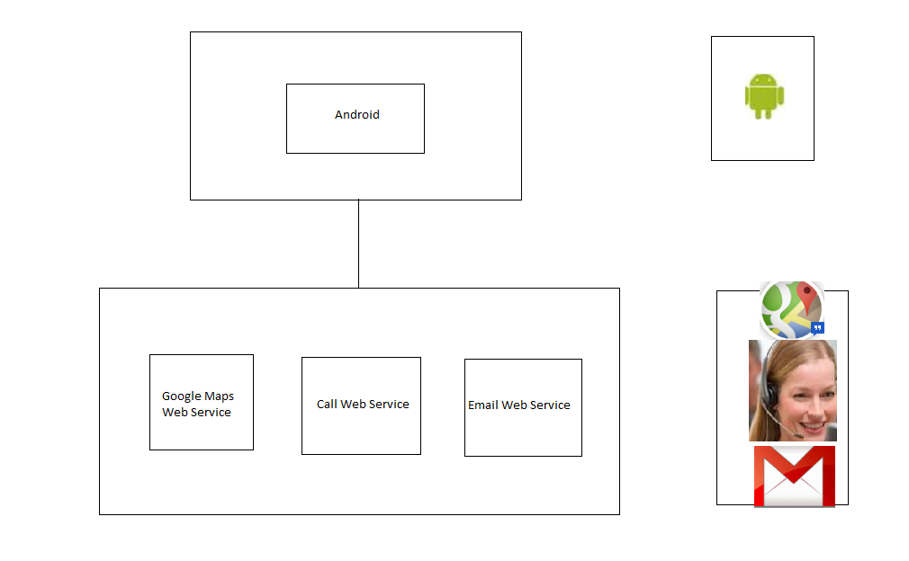

**b. Class Diagram**

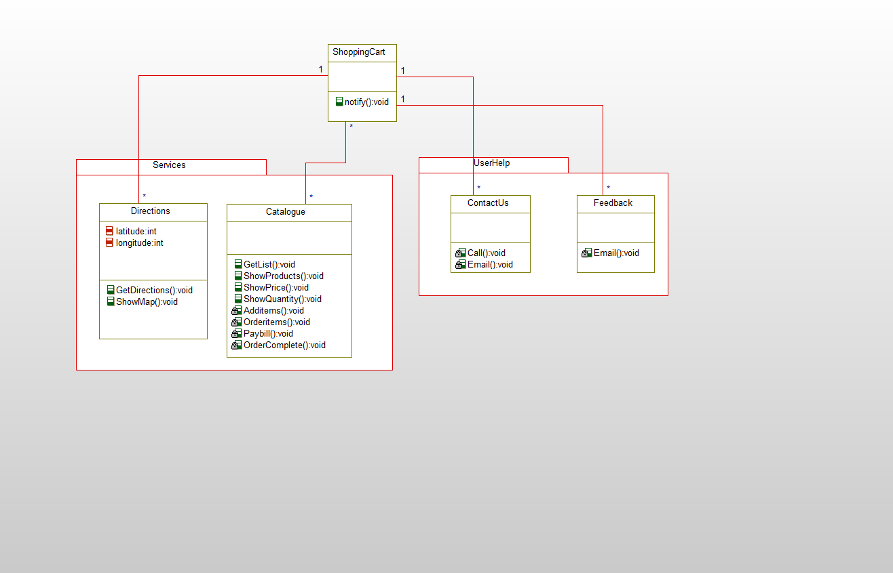

1. **Features Implemented**
2. **Web Services**

* Google Maps Web Service
* Call Web Service
* Email Web Service

1. **Your own services**

Catalogue

Make Payment

Feedback

1. **Existing services/APIs**

Google Maps API

1. **Database**

The Database field includes the data of the store, like where is the store located and how to reach the store from different locations which includes the Google Maps service. Then the available items of the store along with their price is stored. Also the call and Email services data is included.

1. **Your own data model/data sources**

Our own data model includes calling the Google Maps web service for providing location help service to the users and helping the users to search according to their requirements like BBQ accessories, Bathroom essentials, Kitchen essentials etc. Providing the users to help us by giving their feedback of what is good and what needs to be improved and also contacting us for any of the service necessary for them in their order.

1. **Existing data model/data sources**

Google Maps API

HTML Web Page

1. **Mobile User Interface**
2. **Your own design**

In this application, the user enters the particular grocery website. If the user is at a different location and wants to get to the store, he/she can use the directions service from the website which will help the user to get to the store by using Google Maps. Then if the customer wants to do online shopping from the mobile, they can go the catalogue service in the website where the available products are listed along with their quantity and price. Here, the user can select the items and add them to the cart. Once the items are finalized, they can pay the amount and complete the order of the products and the payment successful message will be displayed on HTML web page. If the user wants to contact the site, they can do so by call or email services provided in the contact us field. If the user wants to give their feedback then they can do by the email service in the feedback field.

1. **Existing design**

We made use of Google Maps, Call and Email Web Services and also used HTML web page for the payment successful web page.

1. **Include Screenshots of the Features**

When the user opens the website, the screen will be displayed as below



The services screen in the website is shown below



When the user selects a particular item, then the items selected are displayed as

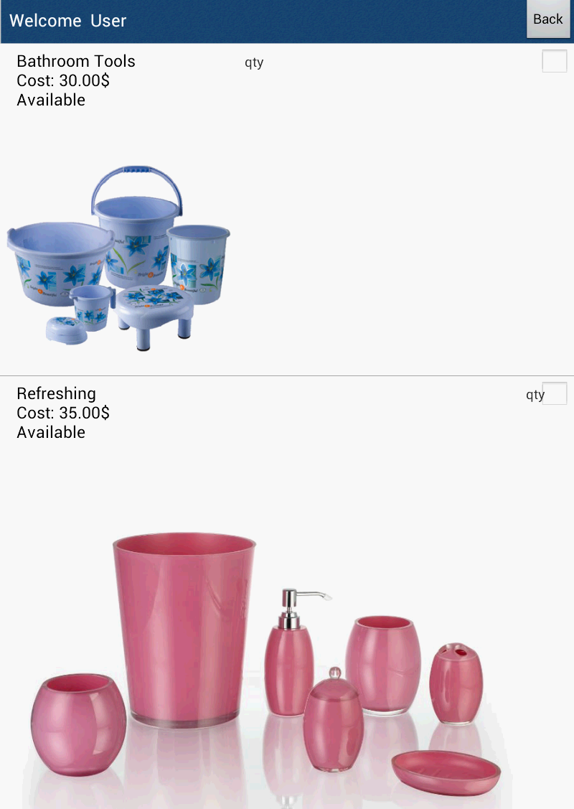

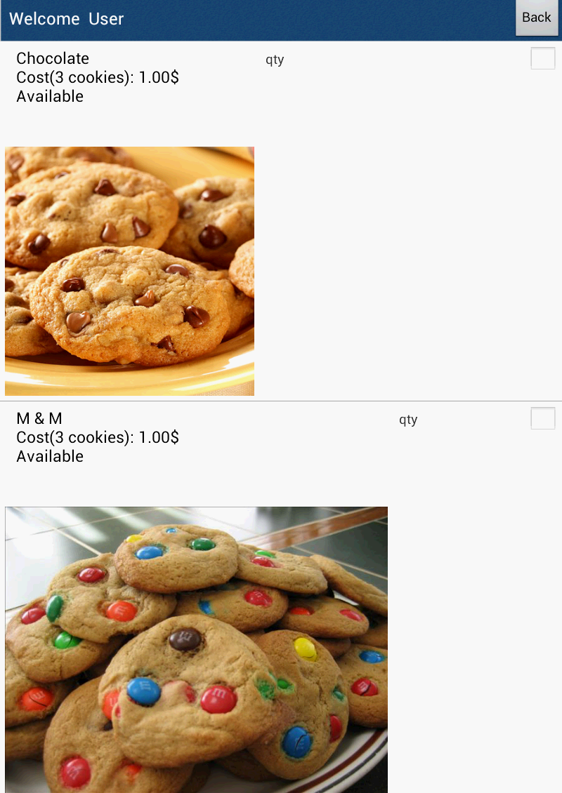

When the user wants to contact by the contact us field then the screen is

shown as 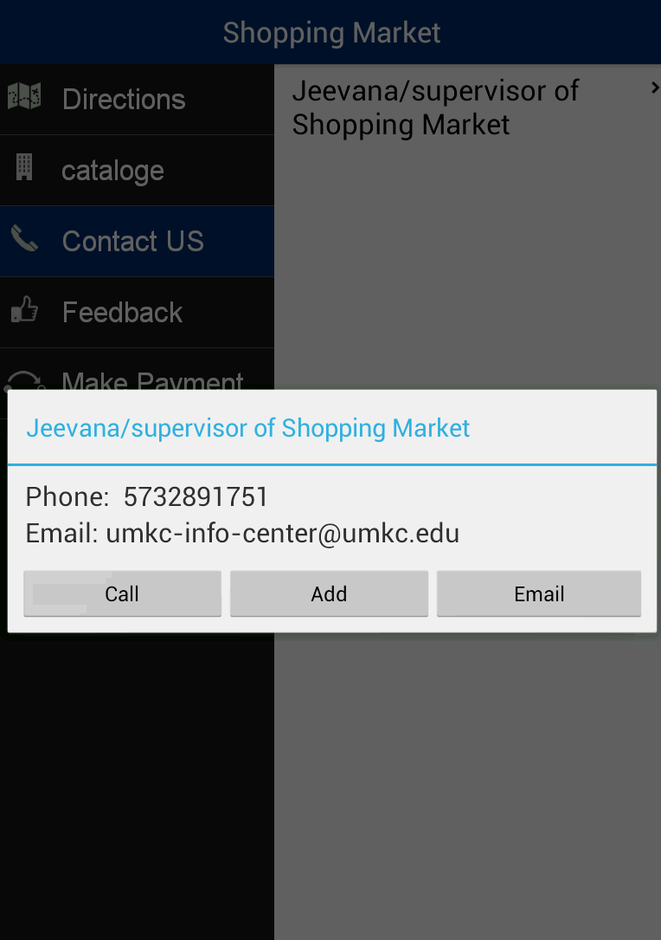



The make payment screen is given as below

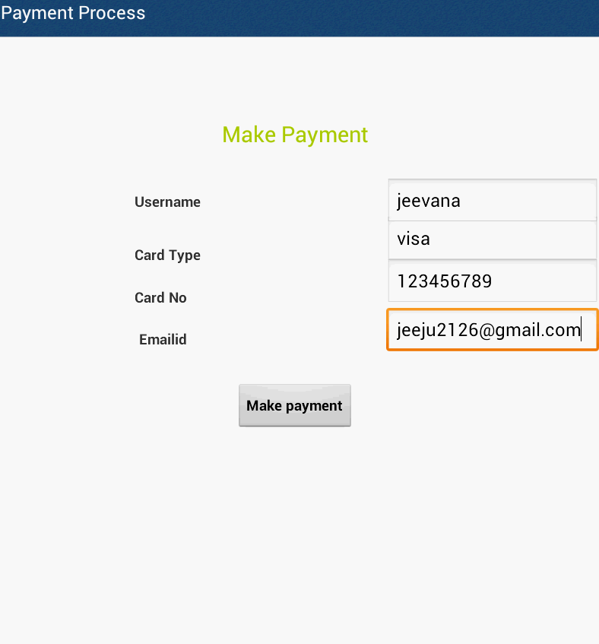

The feedback screen is as follows

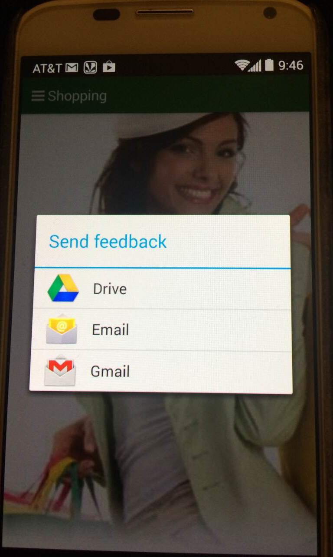

The payment successful screen using HTML is shown as

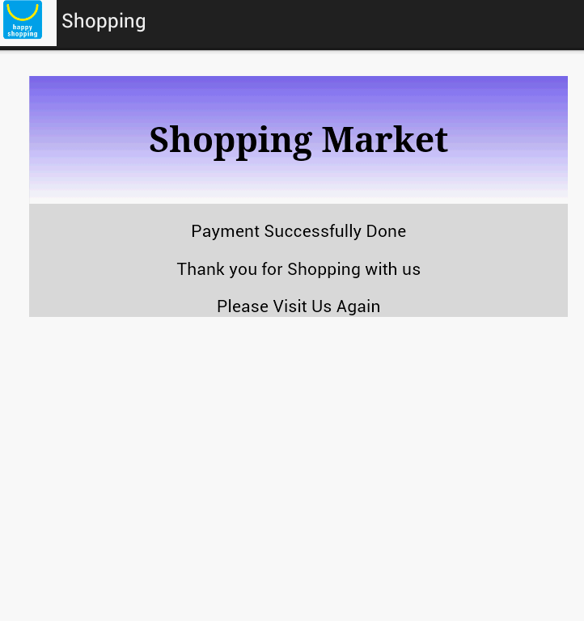

**4) Include all the Web Service and Web Site URLs**

Google Maps Web Service

Call Web Service

Email Web Service

**5)Include your Challenge#1 Github URL**

**https://github.com/jeeju/AseChallenge1**

**6) Limitations**

1. We didn’t used paypal services for making payment.
2. The user survey is not shown with the advice shown from other users
3. We didn’t make use of multi lingual services for our application.

**7) References**

[**http://developer.android.com/index.html**](http://developer.android.com/index.html)

[**http://developer.android.com/guide/webapps/index.html**](http://developer.android.com/guide/webapps/index.html)

[**https://www.coursera.org/course/android**](https://www.coursera.org/course/android)

[**http://www.walmart.com/cp/Walmart-Mobile-App/1087865**](http://www.walmart.com/cp/Walmart-Mobile-App/1087865)

[**http://www.cozi.com/androidapp.htm**](http://www.cozi.com/androidapp.htm)

**Challenge II**

**Design**

In this application, the employee login with his/her details into the site and then there will be different features like ‘food catalogue’ which describes the category of the food i.e. if the food comes under the category of breakfast, spicy food or desserts etc and the other feature like the ‘places nearby’ which gives the list of places nearby when the name of the restaurant is given and the other feature like contact us which helps the hotels or restaurants to contact when they can donate food and the other ‘Feedback’ in which either the hotels/restaurants or the code NGO’s can give their feedback on the service provided and the other feature like the ‘Google Maps’ in which either the NGO’s go or the hotels/restaurants come to give food and if they are unaware of the address they can take the help of Google maps provided by the app and other feature, the ‘Bar Code Scanner’, in which the bar code of the food can be scanned.

1. **Architecture Diagram**

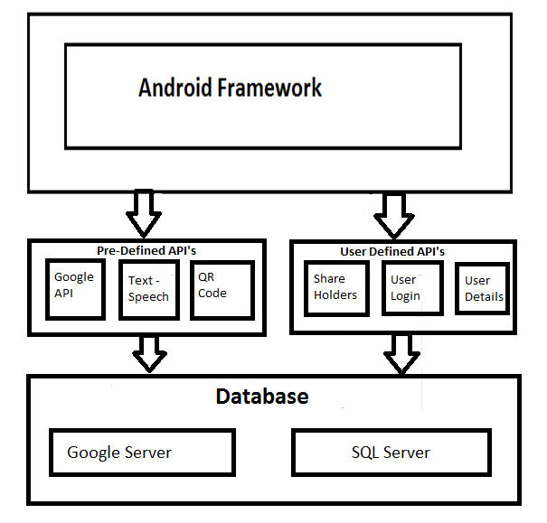

**b. Class Diagram**



**2) Features Implemented**

1. **Web Services**

Employee Login Web service

Employee details Web service

Share Holders Web Service

Google Maps Web Service

Call Web Service

Email Web Service

1. **Your own services**

Food Supply

Make donation

Places nearby

Feedback

**ii. Existing services/APIs**

Google Maps API

Text to speech API

Places nearby API

QR Code API

1. **Database**

We are creating RESTful services. These services will be used for User details, Restaurant/hotel details and NGO’s details.

1. **Your own data model/data sources**

Our own data model includes calling the Google Maps web service for providing location help service to the restaurants/hotels and to NGO’s and helping the NGO’s to search according to their requirements like the kind of food they need. Providing the restaurants or NGO’s to help us by giving their feedback of what is good and what needs to be improved and also contacting us for any of the service necessary for them in their order and also providing with the places according to their search.

1. **Existing data model/data sources**

Google Maps API

Places nearby API

QR Code API

Text to Speech API

1. **Mobile User Interface**

**i. Your own design**

In this application, the employee login with his/her details into the site and then there will be different features like ‘food catalogue’ which describes the category of the food i.e. if the food comes under the category of breakfast, spicy food or desserts etc and the other feature like the ‘places nearby’ which gives the list of places nearby when the name of the restaurant is given and the other feature like contact us which helps the hotels or restaurants to contact when they can donate food and the other ‘Feedback’ in which either the hotels/restaurants or the code NGO’s can give their feedback on the service provided and the other feature like the ‘Google Maps’ in which either the NGO’s go or the hotels/restaurants come to give food and if they are unaware of the address they can take the help of Google maps provided by the app and other feature, the ‘Bar Code Scanner’, in which the bar code of the food can be scanned. The restaurants contact the system and the system contact the NGO’s in order to know their requirement.

1. **Existing design**

We made use of Google Maps, Call, Email, Employee Login, Employee details and shareholders Web Services and also used different API’s like the Text to Speech, Places nearby and QR Code scanner.

**3) Include Screenshots of the Features**

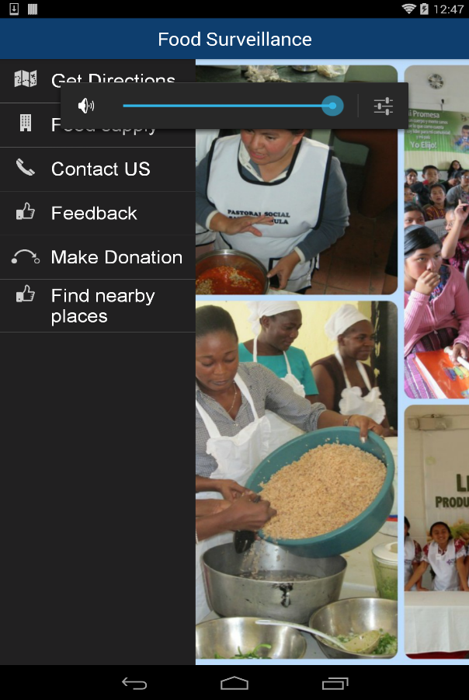

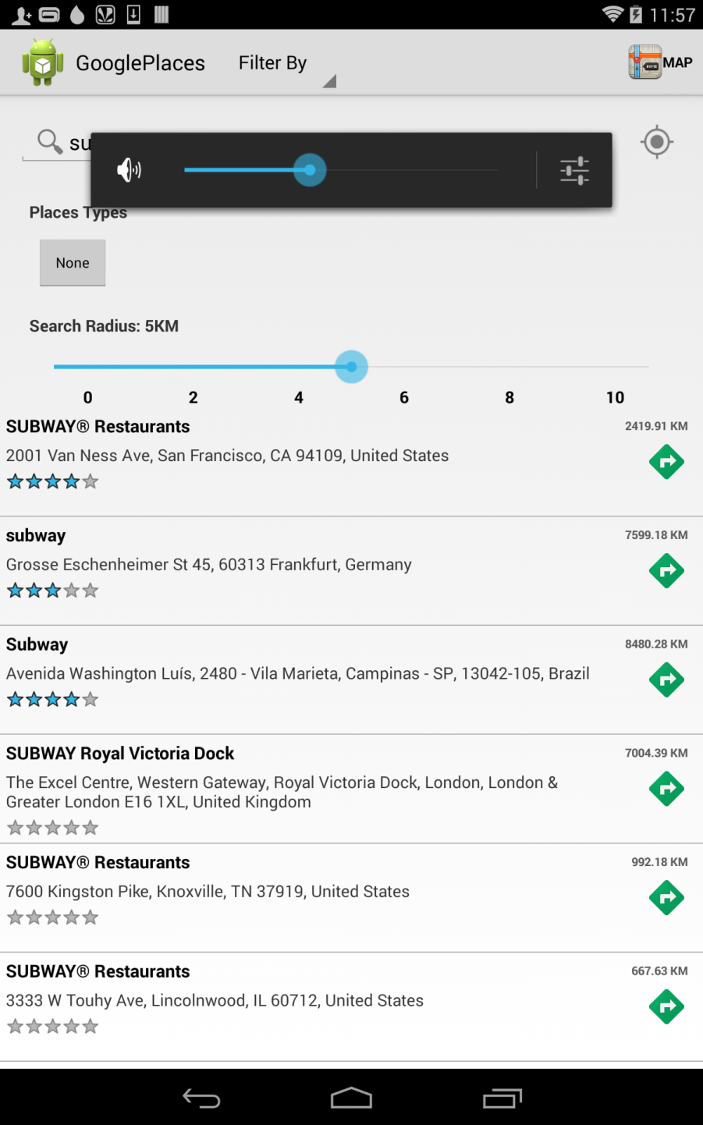

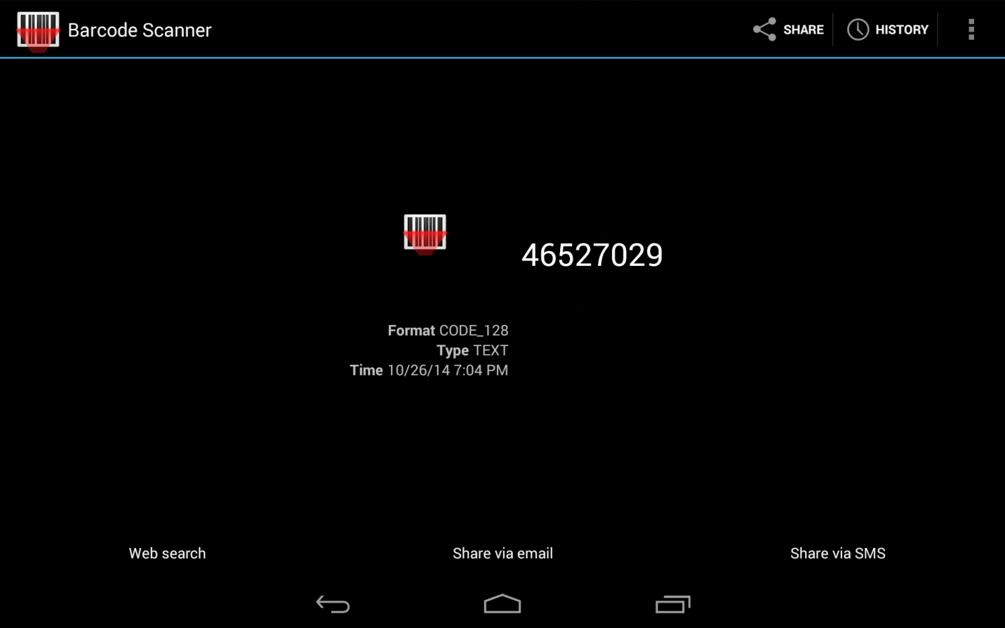

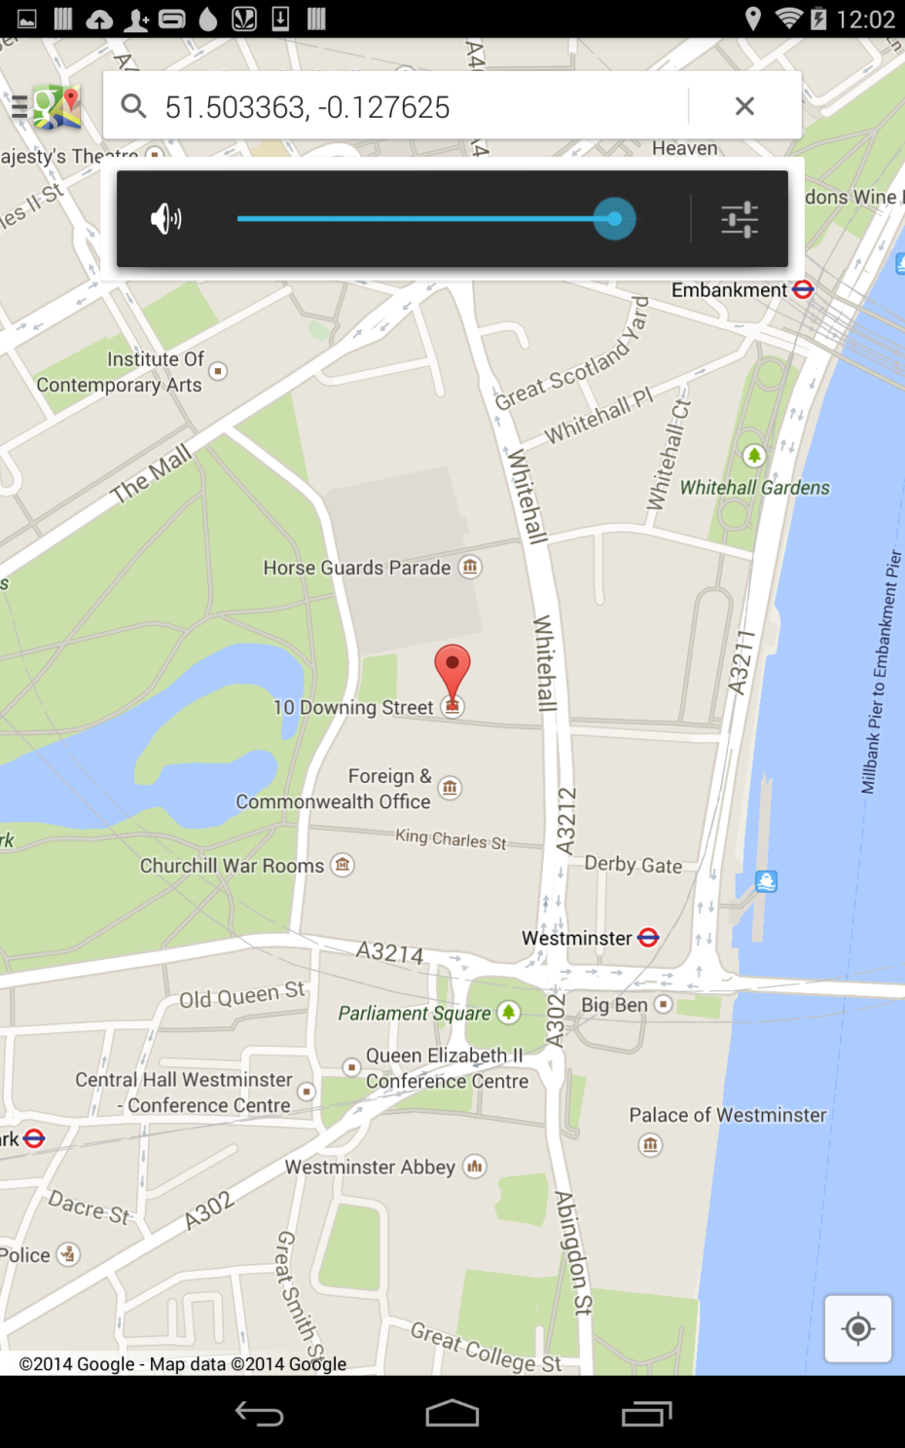

**4) Include all the Web Service and Web Site URLs**

Google Maps Web Service

Call Web Service

Email Web Service

Employee Login Web Service

Employee details Web Service

Shareholders Web Service

[**http://localhost:59330/Service1.svc/queryInfo/%7BuserName%7D/%7BpassWord**](http://localhost:59330/Service1.svc/queryInfo/%7BuserName%7D/%7BpassWord)

[**http://localhost:59330/Service1.svc/insertInfo/%7BuserName%7D/%7BpassWord%7D/%7BcompanyName%7D/%7BcompanyAddress**](http://localhost:59330/Service1.svc/insertInfo/%7BuserName%7D/%7BpassWord%7D/%7BcompanyName%7D/%7BcompanyAddress)

**5) Include your Challenge#2 Github URL**

[**https://github.com/jeeju/CS551_ASEChallenge2/**](https://github.com/jeeju/CS551_ASEChallenge2/)

**6) Limitations**

- The QR Code scanner will not be available for all the products and hence made use of bar code scanner.

- Limited number of food supply and also limited number of food suppliers.

**-** Our application is location specific and can only be used with in that particular location.

**7) References**

[**http://goqr.me/api/**](http://goqr.me/api/)

[**https://github.com/honestwalker/OpenCart-API-service-by-Kancart.com-Mobile**](https://github.com/honestwalker/OpenCart-API-service-by-Kancart.com-Mobile)

[**https://github.com/iankionisala/Online-Ordering-Application**](https://github.com/iankionisala/Online-Ordering-Application)

[**https://developers.google.com/places/documentation/?csw=1**](https://developers.google.com/places/documentation/?csw=1)

[**https://dvcs.w3.org/hg/speech-api/raw-file/tip/speechapi.html**](https://dvcs.w3.org/hg/speech-api/raw-file/tip/speechapi.html)

[**http://developer.android.com/index.html**](http://developer.android.com/index.html)

[**http://www.cozi.com/androidapp.htm**](http://www.cozi.com/androidapp.htm)

INCREMENT-2

**Import Existing Services/API**

Google Maps API

Text to speech API

Places nearby API

QR Code API

Employee Login Web service

Employee details Web service

Share Holders Web Service

Google Maps Web Service

Call Web Service

Email Web Service

**Detail Design of Services**

WSDL: Service description

In this application, the employee login with his/her details into the site and then there will be different features like ‘food catalogue’ which describes the category of the food i.e. if the food comes under the category of breakfast, spicy food or desserts etc and the other feature like the ‘places nearby’ which gives the list of places nearby when the name of the restaurant is given and the other feature like contact us which helps the hotels or restaurants to contact when they can donate food and the other ‘Feedback’ in which either the hotels/restaurants or the code NGO’s can give their feedback on the service provided and the other feature like the ‘Google Maps’ in which either the NGO’s go or the hotels/restaurants come to give food and if they are unaware of the address they can take the help of Google maps provided by the app and other feature, the ‘Bar Code Scanner’, in which the bar code of the food can be scanned.

Sequence diagram (using Visio)



Class diagram (using Visio)



Design of Mobile Client Interface

In this application, the employee login with his/her details into the site and then there will be different features like ‘food catalogue’ which describes the category of the food i.e. if the food comes under the category of breakfast, spicy food or desserts etc and the other feature like the ‘places nearby’ which gives the list of places nearby when the name of the restaurant is given and the other feature like contact us which helps the hotels or restaurants to contact when they can donate food and the other ‘Feedback’ in which either the hotels/restaurants or the code NGO’s can give their feedback on the service provided and the other feature like the ‘Google Maps’ in which either the NGO’s go or the hotels/restaurants come to give food and if they are unaware of the address they can take the help of Google maps provided by the app and other feature, the ‘Bar Code Scanner’, in which the bar code of the food can be scanned. The restaurants contact the system and the system contact the NGO’s in order to know their requirement.

We made use of Google Maps, Call, Email, Employee Login, Employee details and shareholders Web Services and also used different API’s like the Text to Speech, Places nearby and QR Code scanner.

**Implementation**

Implementation of services

Google Maps Web Service

Call Web Service

Email Web Service

Employee Login Web Service

Employee details Web Service

Shareholders Web Service

Implementation of user interface (Mobile Apps)

In this application, the employee login with his/her details into the site and then there will be different features like ‘food catalogue’ which describes the category of the food i.e. if the food comes under the category of breakfast, spicy food or desserts etc and the other feature like the ‘places nearby’ which gives the list of places nearby when the name of the restaurant is given and the other feature like contact us which helps the hotels or restaurants to contact when they can donate food and the other ‘Feedback’ in which either the hotels/restaurants or the code NGO’s can give their feedback on the service provided and the other feature like the ‘Google Maps’ in which either the NGO’s go or the hotels/restaurants come to give food and if they are unaware of the address they can take the help of Google maps provided by the app and other feature, the ‘Bar Code Scanner’, in which the bar code of the food can be scanned. The restaurants contact the system and the system contact the NGO’s in order to know their requirement.

**Deployment**:

Include your project ScrumDo link to the report

[http://www.scrumdo.com/projects/project/ase-fall-2014-umkc- project1/iteration/111373](http://www.scrumdo.com/projects/project/ase-fall-2014-umkc-%20%20%20%20%20%20%20%20%20project1/iteration/111373)

Github URL

[**https://github.com/jeeju/CS551_ASEChallenge2/**](https://github.com/jeeju/CS551_ASEChallenge2/)

Screenshots and explanation on the design, implementation and testing.

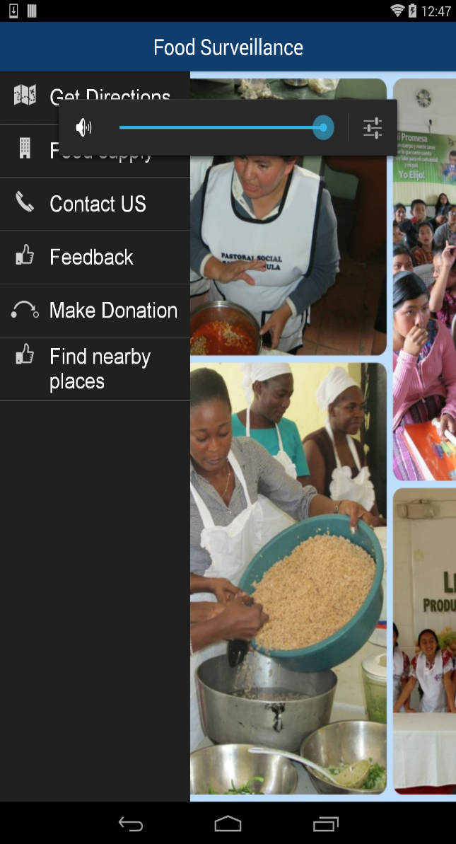



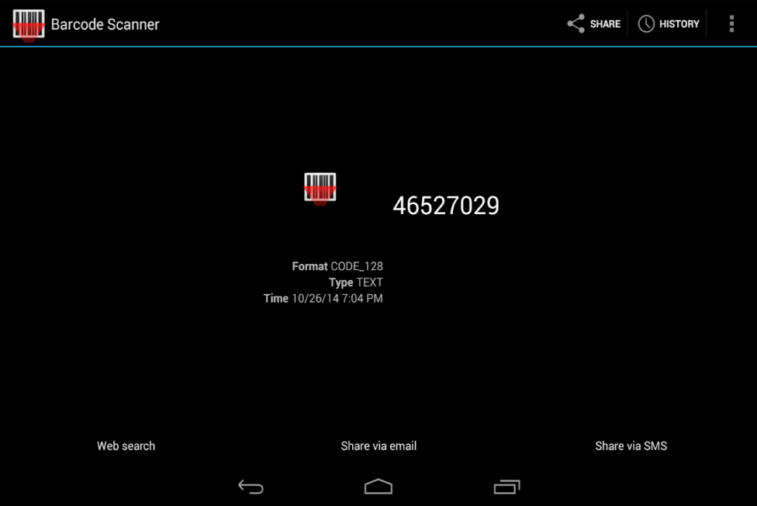

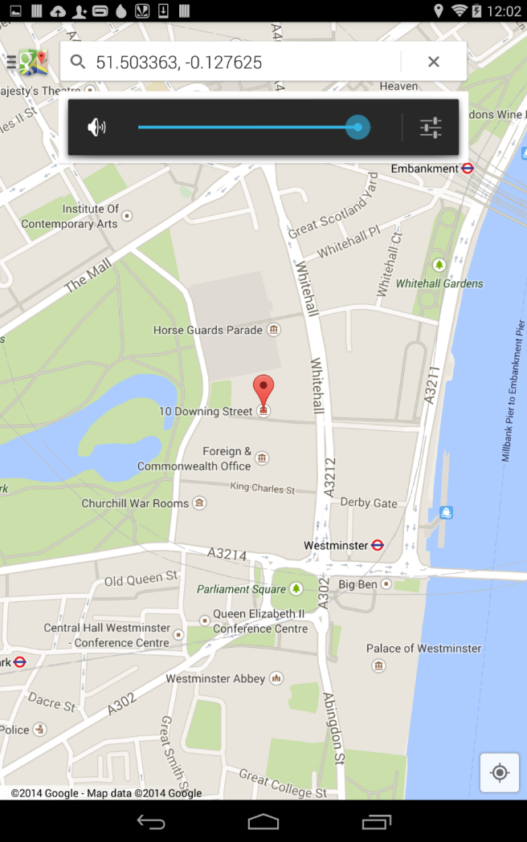

Our own data model includes calling the Google Maps web service for providing location help service to the restaurants/hotels and to NGO’s and helping the NGO’s to search according to their requirements like the kind of food they need. Providing the restaurants or NGO’s to help us by giving their feedback of what is good and what needs to be improved and also contacting us for any of the service necessary for them in their order and also providing with the places according to their search.

**Project Management**:

* <http://www.scrumdo.com/projects/project/ase-fall-2014-umkc-project1/iteration/111373>

Implementation status report

* + - Work completed:
      * Description

Completed almost half of the project and we are trying to add the remaining during the third increment to our project.

* + - * Responsibility (Task, Person)

Jeevana: Did all the Android part

Goutham: SQL related part

Rakesh: Web services part

Saitejasree: API’s part.

* + - * Time taken (#hours)

Took about 20 hours.

* + - * Contributions (members/percentage)

Jeevana: 25%

Goutham: 25%

Rakesh: 25%

Saitejasree: 25%

* + - Work to be completed
      * Description

We should add the other services that are required for our project and are planning to get a clear idea of what are the modifications to be done and add them during the third increment.

* + - * Responsibility (Task, Person)

Jeevana: Android part

Goutham: SQL related part

Rakesh: Web services part

Saitejasree: API’s part

**Issues/Concerns**

* The QR Code scanner will not be available for all the products and hence made use of bar code scanner.
* Limited number of food supply and also limited number of food suppliers.
* Our application is location specific and can only be used with in that particular location.

**Challenge III**

**IBM Bluemix Survey**

Introduction:

The application we are developing is providing a survey about bluemix resources and its services. This is a mobile based Cloud Application exclusively for UMKC Students. In this application we are providing a survey which will be taken by UMKC students by logging in using their SSO and password. Once they enter the survey they can take the survey. They even can comment on any of the issues or solutions they need to know or just give their feedback. This will help both the users and also the Bluemix to improve their way of providing services if any necessary.

Services Used:

* In this application, we are making use of the Mobile data provided by Bluemix and also the three property keys provided for Mobile Cloud Applications and also the Android platform.

Screenshot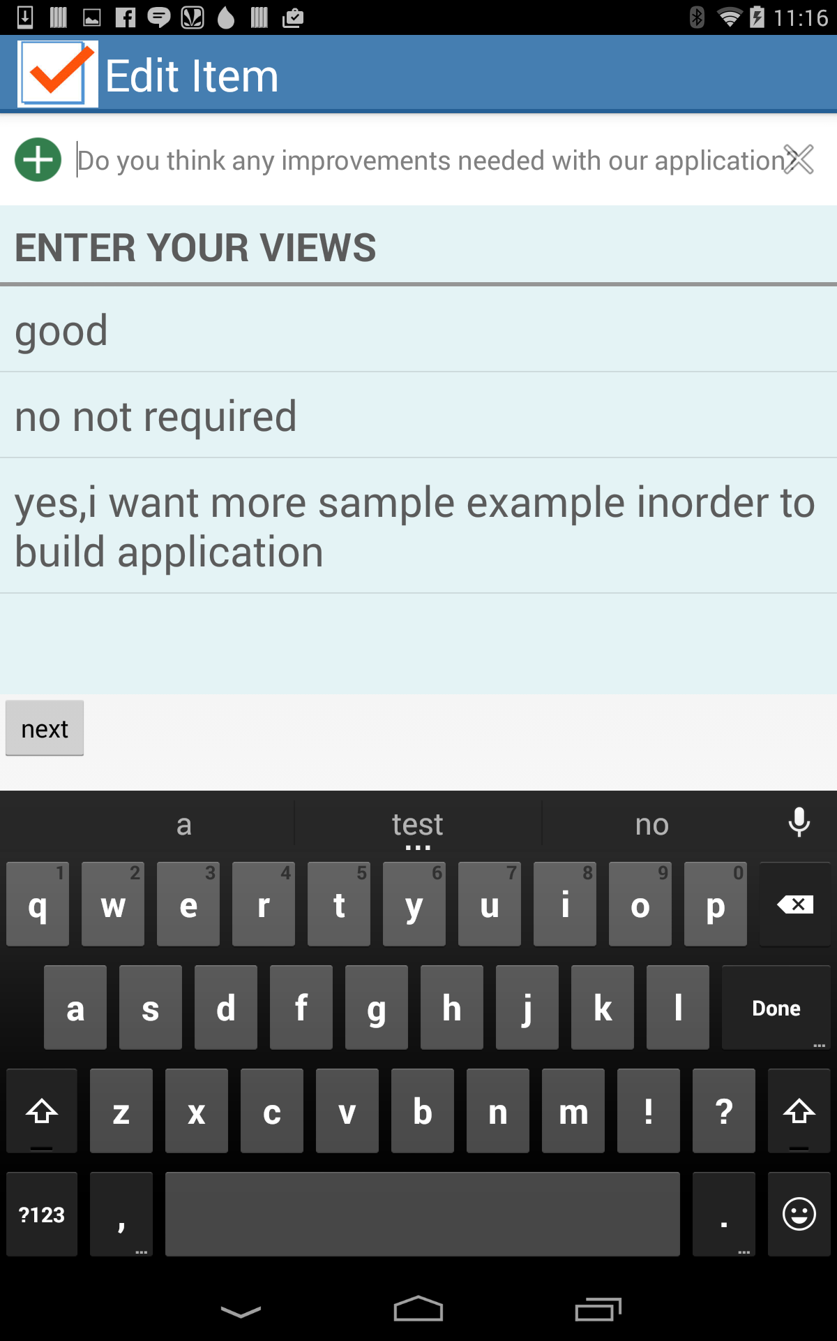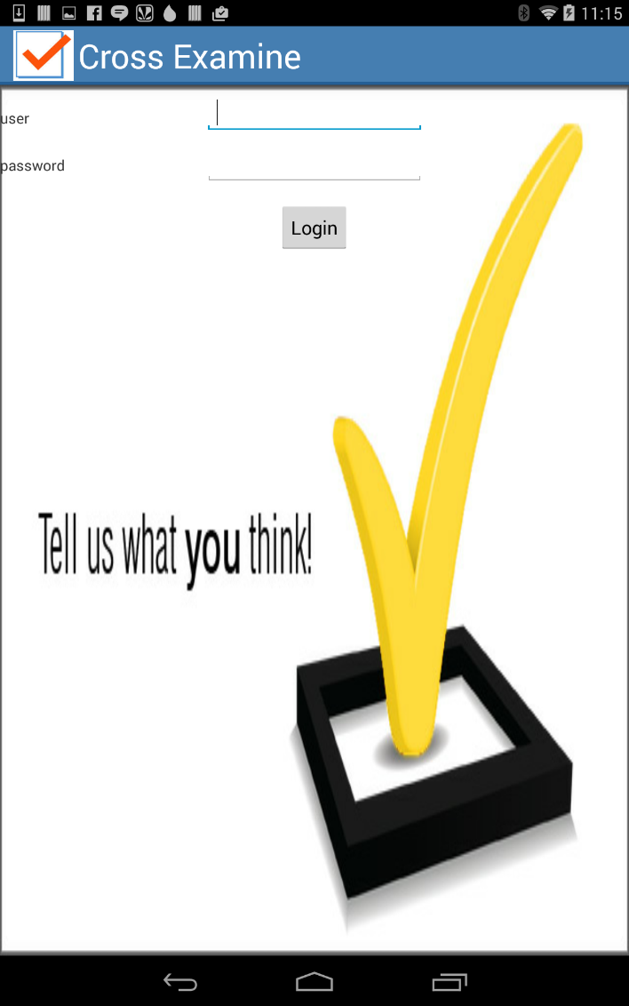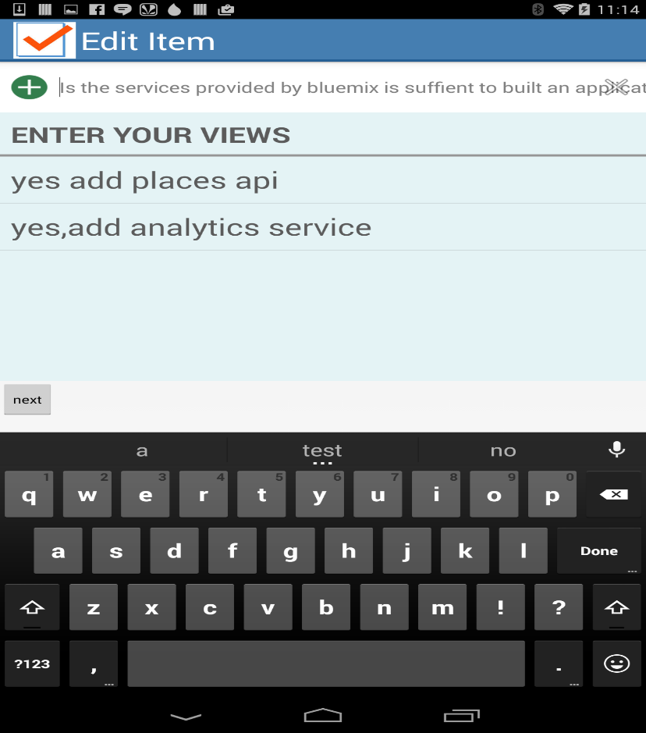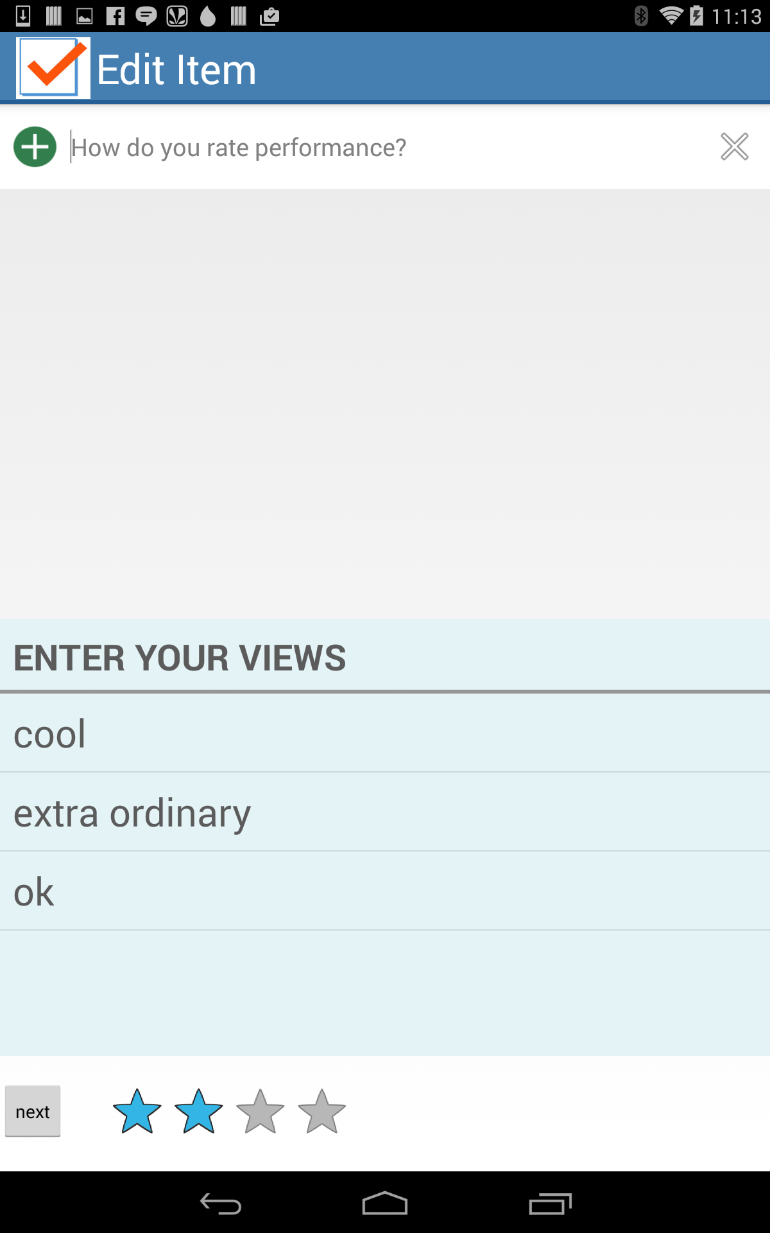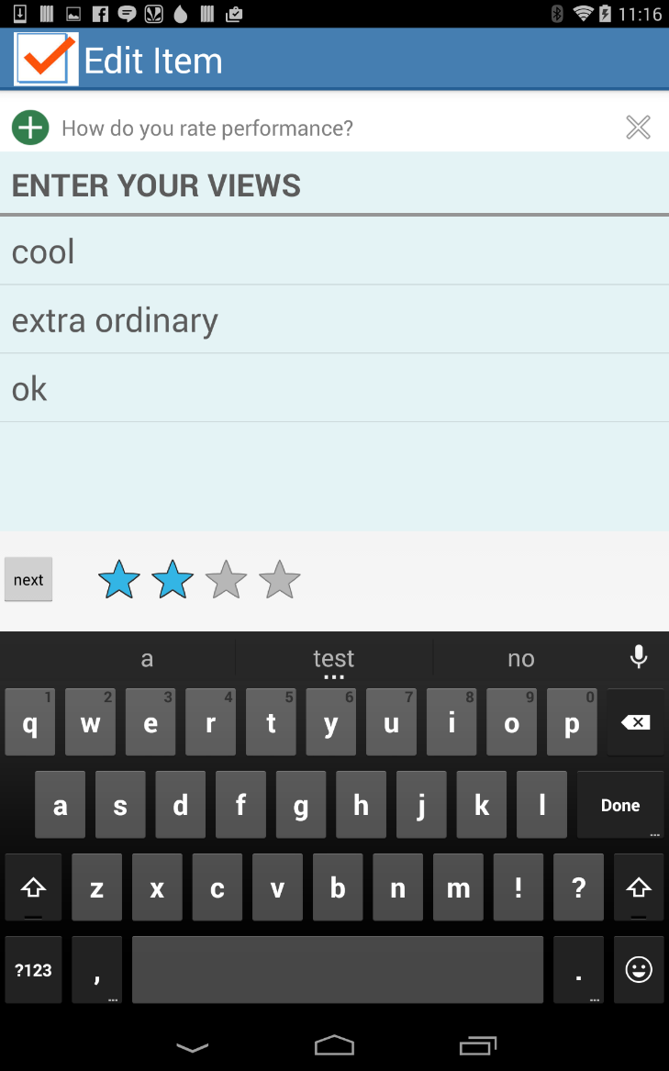

INCREMENT-3

**Import Existing Services/API**

Google Maps API

Login service

Employee Login Web service

Employee details Web service

Google Maps Web Service

Call Web Service

Email Web Service

**Detail Design of Services**

WSDL: Service description

In this application, the employee login with his/her SSO details into the site and then there will be different features like displaying location, donating food, clothes and money and also if there are any health campaigns which describes the category of the food i.e. if the food comes under the category of American food, Indian food, etc and the other feature like donating food or clothes which helps in donating food or clothes of whatever they can afford and also other feature like contact us which helps the hotels or restaurants to contact when they can donate food or clothes and the other ‘Feedback’ in which either the hotels/restaurants or the code NGO’s can give their feedback on the service provided and the other feature like the ‘Google Maps’ in which either the NGO’s go or the hotels/restaurants come to give food or clothes.

Sequence diagram (using Visio)



Class diagram (using Visio)



**Design of Mobile Client Interface**

In this application, the employee login with his/her SSO details into the site and then there will be different features like displaying location, donating food, clothes and money and also if there are any health campaigns which describes the category of the food i.e. if the food comes under the category of American food, Indian food, etc and the other feature like donating food or clothes which helps in donating food or clothes of whatever they can afford and also other feature like contact us which helps the hotels or restaurants to contact when they can donate food or clothes and the other ‘Feedback’ in which either the hotels/restaurants or the code NGO’s can give their feedback on the service provided and the other feature like the ‘Google Maps’ in which either the NGO’s go or the hotels/restaurants come to give food or clothes.

We made use of Google Maps, Call, Email, Employee Login and Employee details web services

**Implementation**

Implementation of services

Google Maps Web Service

Call Web Service

Email Web Service

Employee Login Web Service

Employee details Web Service

Implementation of user interface (Mobile Apps)

In this application, the employee login with his/her SSO details into the site and then there will be different features like displaying location, donating food, clothes and money and also if there are any health campaigns which describes the category of the food i.e. if the food comes under the category of American food, Indian food, etc and the other feature like donating food or clothes which helps in donating food or clothes of whatever they can afford and also other feature like contact us which helps the hotels or restaurants to contact when they can donate food or clothes and the other ‘Feedback’ in which either the hotels/restaurants or the code NGO’s can give their feedback on the service provided and the other feature like the ‘Google Maps’ in which either the NGO’s go or the hotels/restaurants come to give food or clothes.

**Deployment**:

Include your project ScrumDo link to the report

[http://www.scrumdo.com/projects/project/ase-fall-2014-umkc- project1/iteration/111373](http://www.scrumdo.com/projects/project/ase-fall-2014-umkc-%20%20%20%20%20%20%20%20%20project1/iteration/111373)

Github URL

[**https://github.com/jeeju/CS551_ASEChallenge2/**](https://github.com/jeeju/CS551_ASEChallenge2/)

Screenshots and explanation on the design, implementation and testing.

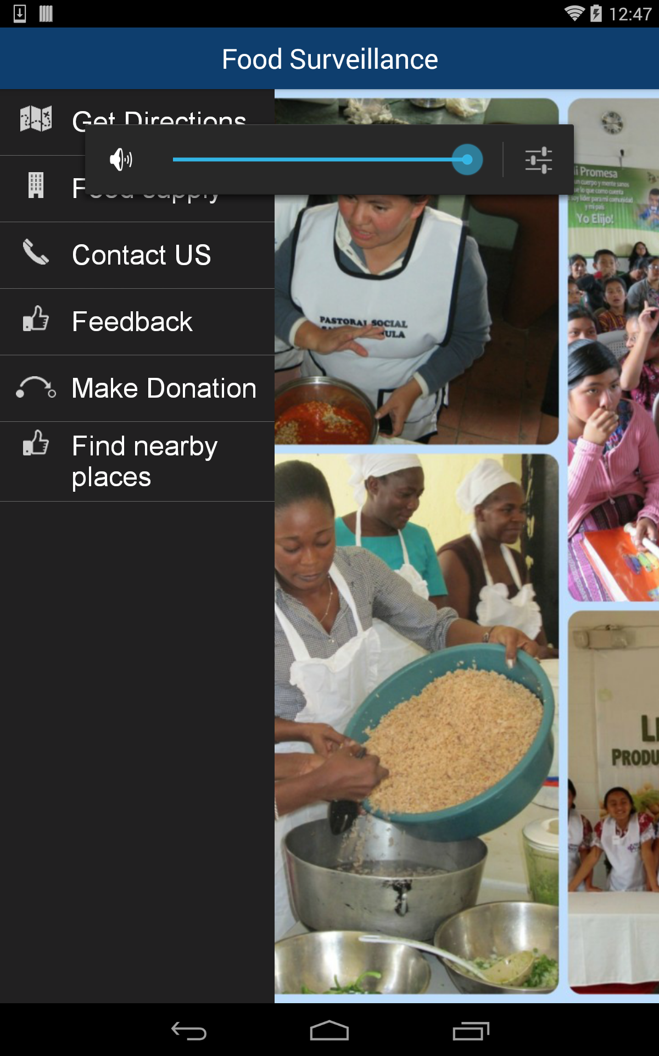



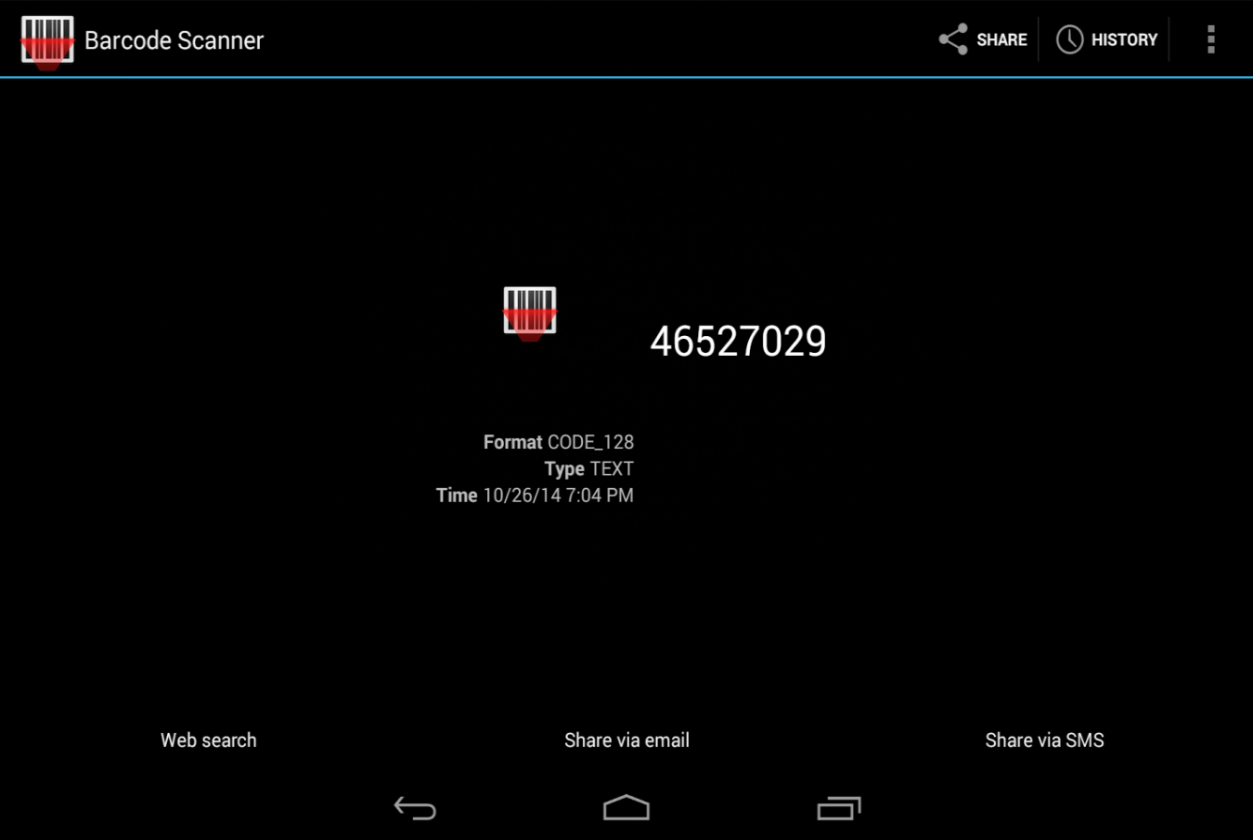



Our own data model includes calling the Google Maps web service for providing location help service to the restaurants/hotels and to NGO’s and helping the NGO’s to search according to their requirements like the kind of food they need. Providing the restaurants or NGO’s to help us by giving their feedback of what is good and what needs to be improved and also contacting us for any of the service necessary for them in their order and also providing with the places according to their search.

**Project Management**:

* <http://www.scrumdo.com/projects/project/ase-fall-2014-umkc-project1/iteration/111373>

Implementation status report

* + - Work completed:
      * Description

Completed almost half of the project and we are trying to add the remaining during the third increment to our project.

* + - * Responsibility (Task, Person)

Jeevana: Did all the Android part

Goutham: SQL related part

Rakesh: Web services part

Saitejasree: API’s part.

* + - * Time taken (#hours)

Took about 20 hours.

* + - * Contributions (members/percentage)

Jeevana: 25%

Goutham: 25%

Rakesh: 25%

Saitejasree: 25%

* + - Work to be completed
      * Description

We should add the other services that are required for our project and are planning to get a clear idea of what are the modifications to be done and add them during the third increment.

* + - * Responsibility (Task, Person)

Jeevana: Android part

Goutham: SQL related part

Rakesh: Web services part

Saitejasree: API’s part